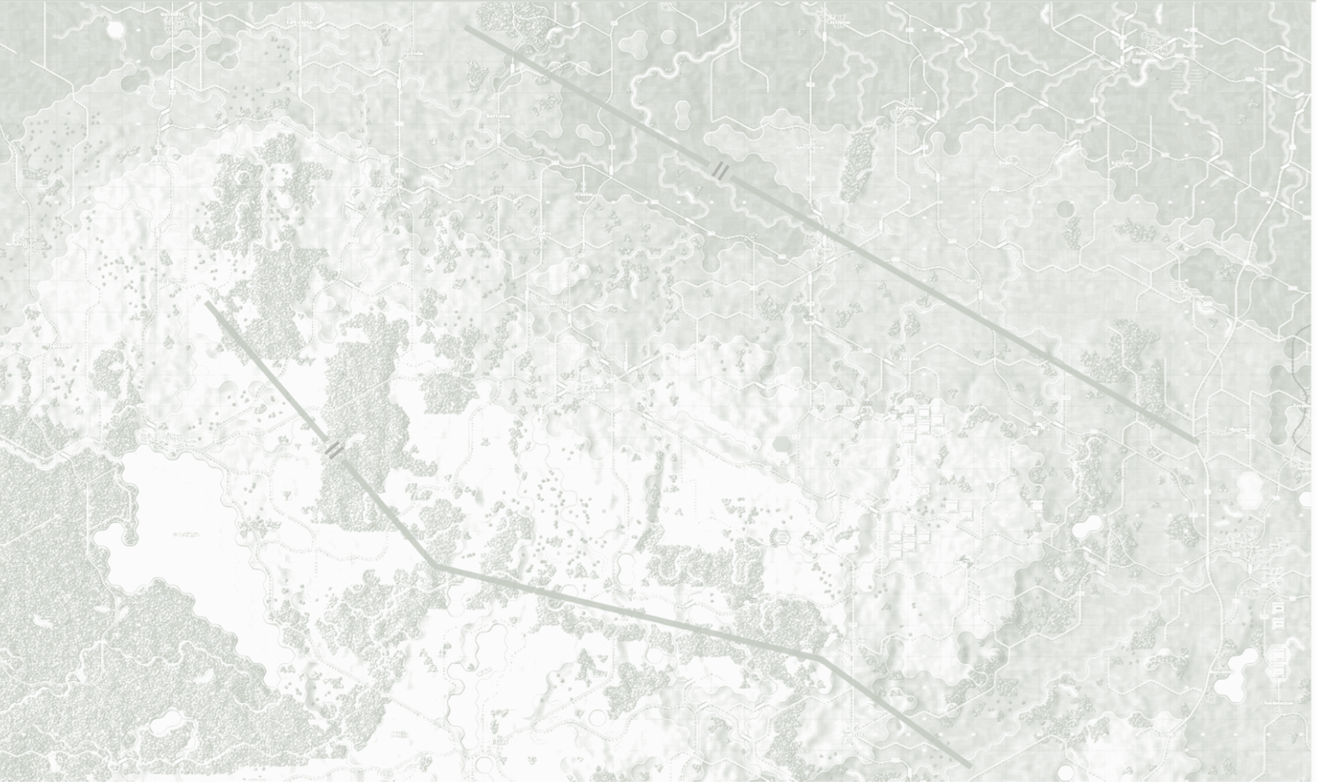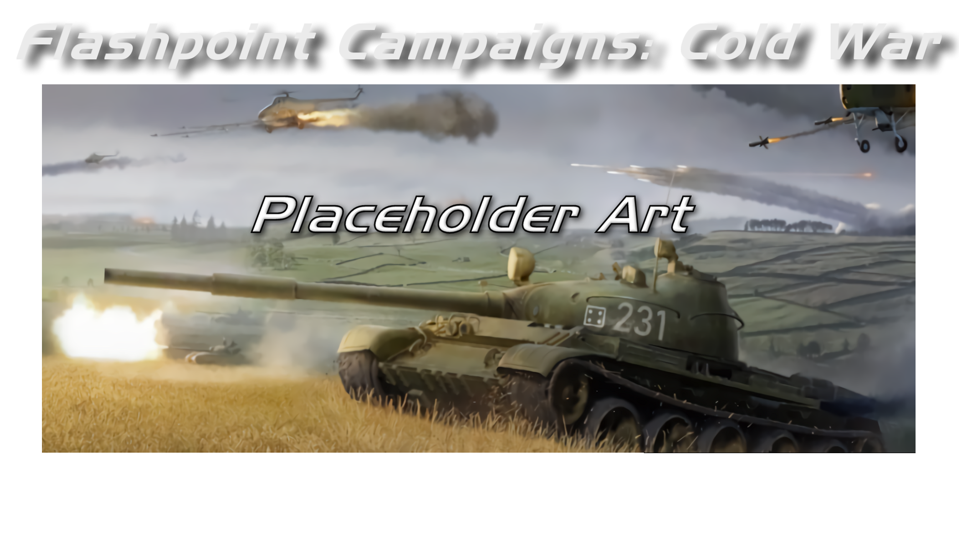

Weather Setup

Field Manual FCCW-10/R1

**© 2025 On Target Simulations (OTS), LTD. All Rights Reserved. The images used and OTS Logo are property of On Target Simulations, LTD. All other marks and trademarks are the property of their respective owners.**

Table of Contents

1 Introduction 4

1.1 What's in This Document 4

1.2 Manuals 5

1.2.1 The Field Manuals (FM) 5

1.2.2 What’s New 5

1.2.3 FPC Hotkeys 5

1.2.4 Flashpoint Campaigns: Cold War FAQ 5

1.3 Gender Pronouns and Inclusion 5

2 Weather System 6

2.1 Weather Elements Supported 6

2.2 Weather Elements Not Supported 6

2.3 Limitations 7

3 Weather in the Game 7

3.1 User-Interface 7

3.2 Weather Forecast 8

3.3 Scenario Editor 9

3.3.1 How to Select Random Weather 10

3.3.2 How to Select Foggy Weather 10

4 Weather Data Files 11

4.1 Weather Station Folders 11

4.2 Weather Data Files 11

4.3 Map to Weather Mapping File 11

4.4 Weather Data File Contents 12

4.5 Weather Data File Contents Rules 13

5 Tips for Creating Your Own Weather Data 14

5.1 Cloning and Manually Modifying 14

5.2 Obtaining and Processing in Bulk 20

5.2.1 Data Source 20

5.2.2 Processing 21

6 Flashpoint Campaigns Credits 22

6.1 On Target Simulations 22

6.2 On Target Simulations Content Team 22

6.3 Cold War Beta Testers 22

6.4 Matrix Production Support 22

7 On Target Simulations on the Web 23

# Introduction

Welcome to FLASHPOINT CAMPAIGNS: COLD WAR

This is a grand tactical combat simulation on the Cold War battlefield. As the force Commander, you will plan and then issue orders and Standard Operating Procedures to your battalion, brigade, or regimental forces shaping the fight by maneuver and your intent. Your forces will engage the enemy on rendered real-world map locations. Each hex is 500m of militarily significant terrain. Each battle can last 4 to 24 hours of in-game time. Your troops will meet their foes any time of day and in any environment.

The game engine is based on asynchronous WEGO turns. This means you will issue orders and then watch a variable amount of time unfold on the battlefield. Then issue or adjust orders to react to what has happened as you execute your battleplan.

***Flashpoint Campaigns: Cold War*** is a deep simulation of combat operations where your forces are arranged in maneuver units of companies, platoons, and sections of tanks, infantry fighting vehicles, infantry squads and teams, recon forces, engineers, air-defense and anti-tank systems, helicopters and more. As the Commander, you must use available off-map assets like long-range artillery, rockets, or airstrikes.

Your efforts in this complex battlespace will be constantly challenged by modeled features like Electronic Warfare, Air Superiority, Realistic Weather, Line of Sight and Fire, Terrain and Elevation, Smoke and Mines, and Human Factors like training, morale, and readiness. All these elements must be considered if you are to be victorious on the battlefield.

The game is packed with information dialogs, map overlays, and range rings to aid you as Commander, master the situation, and understand your force’s capabilities.

***Flashpoint Campaigns: Cold War*** is a data-rich simulation where each nation has information on National Characteristics, Command Parameters, and Orders of Battle. Data Tables are packed with era-specific equipment and troops. Weapon Systems of the time, such as guns, missiles, precision munitions, small arms, and much more, are comprehensively modeled.

As a toolkit, you can create your own scenarios and campaigns. You can also dive deeper and create or modify game data, artwork, and sound effects as you see fit. All these modding capabilities are supported by detailed documentation.

* 1. What's in This Document

This document explains how to set up weather for the game’s realistic weather conditions. This includes information on how to set weather for a scenario and how to make or modify weather data files for use in your own scenarios or maps.

**NOTE:** Areas of interest or buttons on form pictures are outlined in red.

**NOTE:** Some images in this manual are from other versions of the game. While your maps and units may be different, all the information and how it is used and displayed will match the information seen in this manual.

## Manuals

We have chosen to go with many living manuals to cover game interface/play, learning the game, basic tactics, Content Creation, and Game Modding for the Cold War game engine. We also have guides that cover that area of operations. The affected manuals and guides will be updated as the game is updated, and PDFs of these changes will be included with the new patches.

### The Field Manuals (FM)

These are the core manuals on how to play, create content for, and modify data for the Cold War game engine. Before jumping into Content Creation, we strongly recommend you review the first three manuals, **Game Operations**, **Battlefield Primer**, and **Tutorial Operations** if you are new to this type of game and warfare. Returning Flashpoint Campaigns players should review **Game Operations** to get details on new features, as there are many.

These documents are found in the Documents\FMs folder.

* FM01: Game Operations – Detailed information on the game, its interface, and how to use it
* FM02: Battlefield Primer – Fighting in the Cold War
* FM03: Tutorial Operations – How to learn and play the game
* FM04: Scenario Design – How to make or edit scenarios
* FM05: Battle Planning – How to create or edit battle plans. Battle Planning is a unique topic of Scenario Design.
* FM06: Campaign Design – How to make or edit campaigns
* FM07: Map Construction – How to make simple maps for the game
* FM08: Game Modifications – How to revise elements of the game
* FM09: Data Structures and Editing – How to edit or build data sets
* FM10: Weather Setup – ***This Manual*** - How to add in weather from other locales
  + 1. What’s New

The What’s New PDFs summarize any changes and fixes when updates are released.

These can be found in the Documents\WhatsNew folder.

* + 1. FPC Hotkeys

This PDF document lists all the unique game key presses for Function keys and all hotkey definitions. There is no ability to rebind due to the large number of functions in the game.

This document is in \Documents folder.

* + 1. Flashpoint Campaigns: Cold War FAQ

To stave off forum-clogging threads on various topics that we either don't control or can't support, we have created this FAQ document with the answers to those specific topics.

Please review the FAQ for answers to several game topics related to the game but not on how to play the game.

This document is in the \Documents folder.

* 1. Gender Pronouns and Inclusion

We understand that our simulation will be played by users of all genders. We try to keep language in the game and manual gender neutral, when possible, but sometimes use the pronoun “he” to refer to the user. This is merely to streamline the writing and is not meant to exclude anyone or note a specific gender.

The On Target Simulations team supports the inclusion of all people in the field of wargaming.

# Weather System

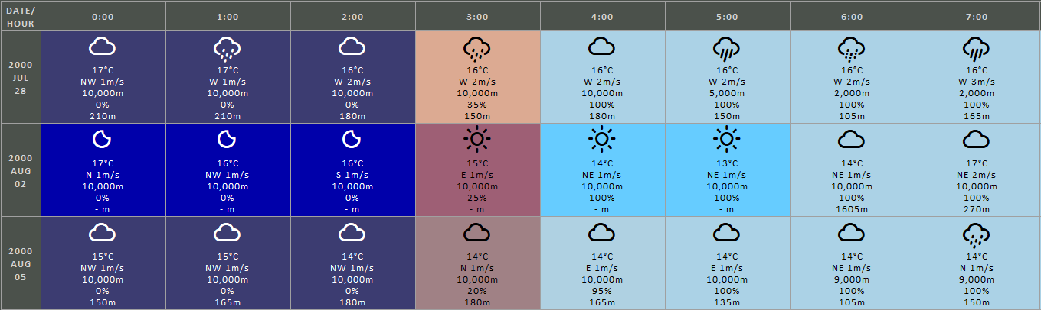  
Figure 1: Weather data (filtered for 'precipitation', as shown in Flashpoint Campaigns’ Scenario Editor)

For the Flashpoint Campaigns game engine, we have introduced a data driven weather system, which presents the commander/player with higher fidelity weather influencing the battle, and with weather forecasts to feed into tactical considerations.

The scenarios included in the game each come with historic weather data, and present (subtle) climate differences between the regions.

The scenario designer can select specific weather types for his scenario, and pick fixed or pseudo-random weather.

Being data driven, the Flashpoint Campaigns weather system enables the user to add new weather, to represent locations and climates different from the West/Central/East-European weather included in the base game.

## Weather Elements Supported

The following weather elements are supported:

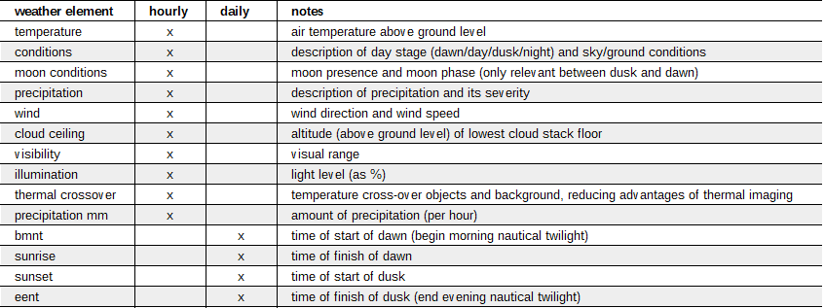

Most of these elements are input to the game’s mechanics.

Many of these weather elements have analogue values (temperature, wind speed, cloud ceiling, visibility, illumination, precipitation amount). The elements with discrete values are listed below:

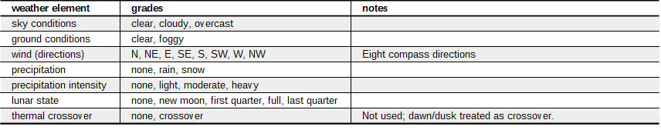

For more details on the exact data input format, see Section **Error! Reference source not found.**.

## Weather Elements Not Supported

As of this version, the following weather elements are not supported:

* Dust storms (reducing visibility)
* Icy surfaces, frozen rivers and snow heights   
  (these can be accounted for in the map’s, by setting mobility values for hex locations, and between hex locations, and by removing water obstacles)
* Hail, sleet (can be approximated by liquid precipitation)
* Lightning (too much detail for a 500m platoon-and-up level game/simulation)
* Wave, surf, and tidal conditions

## Limitations

All the game’s map areas are assumed to have the exact same weather. Generally, with most map sizes 20x15km and 40x30km, this is a fair approximation. However, it falls short in representing valley floor ground fog in mountainous regions.

The game does not support time zones. Make sure the weather data is defined in time matching (or close to) the local time zone, so dawn and dusk times feel natural in the scenario.

Dawn should occur no earlier than 00:00hrs (not in the preceding evening) and dusk no later than 23:00hrs (not in the next morning).

The minimum amount of weather required for a scenario is 24 + 23 hours, from 00:00hrs on the day of the scenario start to 23:00hrs on the day after the scenario start. This is because the Scenario Editor allows scenarios to last for maximum 24 hours and start at 23:00hrs latest.

# Weather in the Game

Weather is presented explicitly in the game, to the player, and to the scenario designer. Having full and consistent weather data is essential to clearly present (and process) the weather in the game.

The Flashpoint Campaigns engine steps through the weather data in 5-minute increments and interpolates between hourly observations.

## User-Interface

The current weather is presented in the ‘current situation’ panel, and implicitly through a map hue.

The bottom part of the turn/clock panel lists:

* Part of day (night, dawn, day, night)
* Cloud conditions and ground conditions
* Precipitation, if any
* Visual range
* Weather icon represents cloud and ground conditions
* Wind direction and speed
* Weather icon represents wind direction
* Illumination level (as percentage)
* Weather icon presenting lunar state (night)
* Next dawn/or dusk times (start- and end-time)
* Cloud base height, and whether the clouds are rising or falling

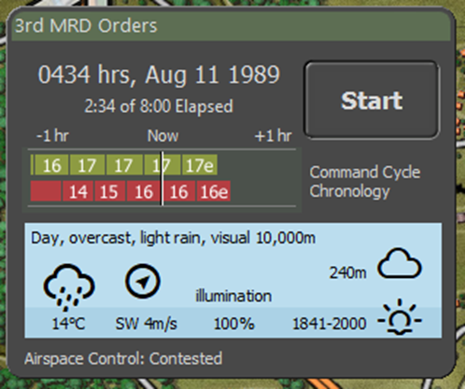

The part of the day, and specifically the transitions from night through dawn to day, and from day through dusk to night, are also indicated by a hue change of the terrain.

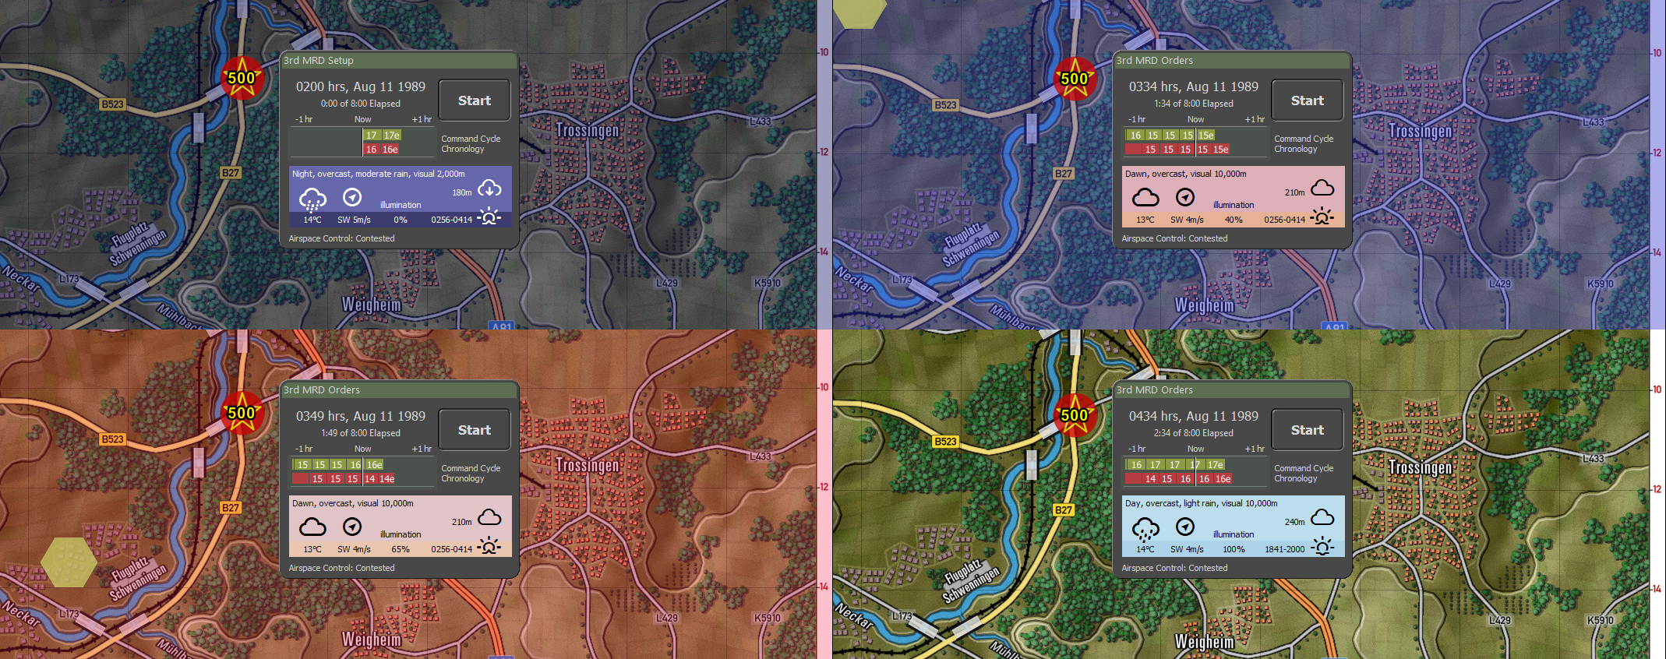

## Weather Forecast

The upcoming weather for the scenario is presented via the TOC Intel panel, in the Weather Forecast tab. Here, a forecast is given for the next 24 hours, along with information on dawn and dusk timings and the lunar phase.

The weather forecast provides information by the hour for the ‘modern era’, and by day part (6 hour, fuzzified) for the ‘Cold War era’.

Additionally, the weather forecast provides a list of systems that might be impacted by those weather conditions (roughly based on US FM 34-81-1).

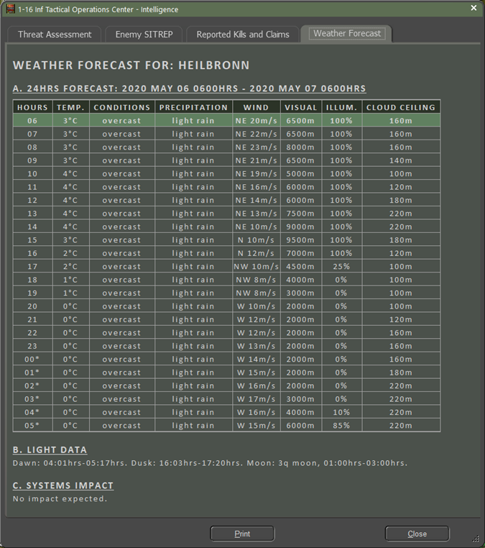

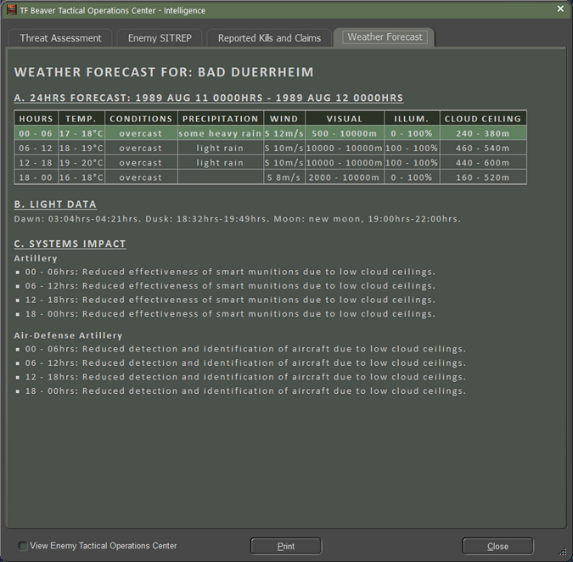

## Scenario Editor

The scenario creator defines the weather for the scenario he creates. The scenario creator either selects a single ‘weather day’, resulting in ‘fixed’ weather for the scenario, or multiple ‘weather days’, resulting in pseudo-random weather for the scenario.

In case of multiple ‘weather days’, one of these ‘weather days’ is picked at random at scenario start time, and used for the duration of the scenario, across saves and reloads of that scenario. Whenever the scenario starts anew, the random selection is performed anew, most likely yielding different weather.

The Scenario Editor’s dialog to select weather (‘weather days’) for is shown below.

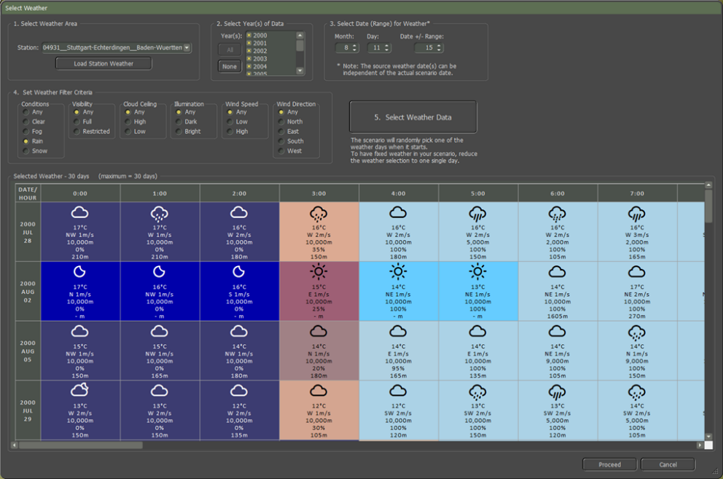

In the Scenario Editor’s ‘Select Weather’ dialog, first the weather station is selected, in ‘1. Select Weather Area’. (If the map used for the scenario shipped with the game, the Scenario Editor will automatically select the matching weather station, based on a configuration file).

By pressing the ‘Load Station Weather’, the game loads the ‘years’ for which the selected station has weather data and shows this in the selection list under ‘2. Select Year(s) of Data’. Select at least one year to continue.

Generally, the year will be after 2000, since weather stations didn’t start collecting and sharing extensive and complete per hour data until digital computers and the Internet became common. For, for example, the Cold War era, we need to use later but regionally representative weather.

Next, pick a date and date range. To pick the weather representative of the scenario’s date, it’s recommended to pick (a range around) that date. For example, for August 13, 1989, scenario, pick the August 13 date. Weather from around August 13 will be representative of the seasonal weather and also have representative dawn and dusk times.

Alternatively, for example, when foggy days are scarce in mid-August, one might try picking weather from April, since this will have similar dawn and dusk times. Whatever, weather is chosen, it is presented to be on the scenario’s date.

As a next step, set weather criteria under ‘4. SetWeather Filter Criteria’. Selecting ‘Any’ for each criterion results in no filtering.

Finally, press the ‘5. Select the Weather Data’ button. After a while, the data is loaded and filtered, the selected weather days (if any), are displayed in the table underneath.

The table shows up to 30 days of selected weather, from 00:00hrs on the selected day until 23:00hrs on the following day. All columns for the following day have their timestamp tagged with ‘*’.

Press ‘Proceed’ to select these ‘weather days’ for your scenario, or press ‘Cancel’ to discard any changes made.

The selected weather data will be included in the scenario and the scenario can be distributed to others without these players being required to have the same weather data files installed on their computer.

### How to Select Random Weather

To select random weather for the scenario, ensure the weather data selection contains more than one ‘weather day’. This can be done in multiple ways:

* Include multiple years in the selection
* Expand the range around the selected weather data (and press the ‘Select Weather Data’ button)
* Relax the filter criteria

Make sure to press the ‘Select Weather Data’ button after making any of the changes.

### How to Select Foggy Weather

To select foggy weather for the scenario, first select ‘Fog’ under ‘4. Set Weather Filter Criteria’, ‘Conditions’. And press the ‘Select Weather Data’ button.

If the result is zero ‘weather days’, then foggy days are scarce for the selected date. To work around this and increase the number of foggy days returned, do:

* Include multiple years in the selection
* Expand the range around the selected weather data (and press the ‘Select Weather Data’ button)

Make sure to press the ‘Select Weather Data’ button after making any of the changes.

If the result still is zero ‘weather days’, consider switching to another area/weather station’s weather.

# Weather Data Files

The weather data is stored in folders and files as part of Flashpoint Campaigns’ game data.

The weather data is stored under Modules/Common in the Weather subfolder. The Weather subfolder also contains a font file defining weather icons (weathericons-regular-webfont.ttf’).

In addition, the Modules/Maps folder contains a ‘meteo_stations.tsv’ file defining the preferred weather station for each map.

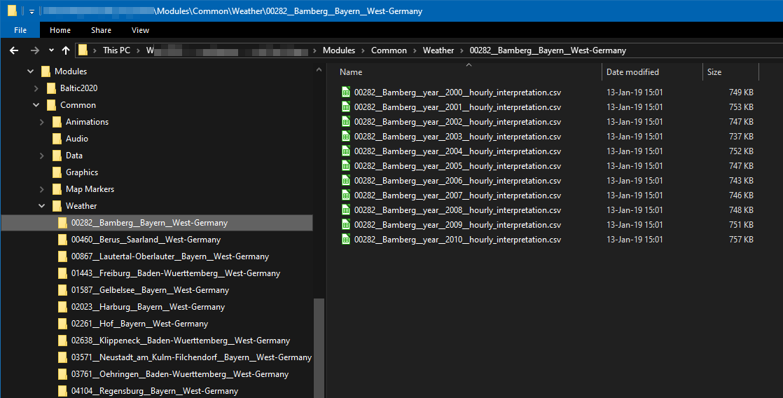

## Weather Station Folders

Under the Modules/Common/Weather folder, each weather station has its own folder. The weather station folder can have any name. Its only contents should be weather data files.

## Weather Data Files

In each station folder under Modules/Common/Weather, there should be at least one weather data file containing one year of hourly weather.

The format for hourly weather data files is: *_year__####_*.csv. In words, the filename should contain a part ‘_year_’ followed by the year (as four digits) and be a .csv file. For example, ‘00282__Bamberg__year__2010__hourly_interpretation.csv’.

See below for its contents.

## Map to Weather Mapping File

In each Module’s Maps folder, there is a file ‘meteo_stations.tsv’ file. Its contents look like this:

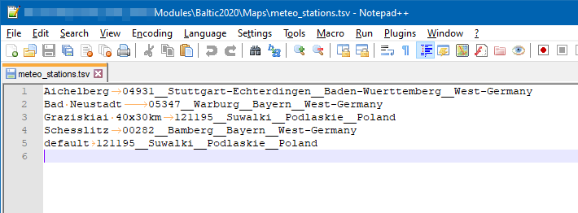

The meteo_stations.tsv file is a tab-separated file, containing two columns. To the left, the map name (without folder, and without file extension). On the same line, on the right of the tab character is the corresponding folder name for the meteo station. For example, on the 3rd line, for map ‘Graziskia 40x30km’ the recommended weather data is in folder ‘121195__Suwalki__Podlaskie__Poland’.

The final entry is a special one, indicating the default weather station for maps not explicitly listed below.

*NOTE: when editing this file, take care to separate the map name and meteo station with a tab character. Make sure to use a (free) programmer’s editor such as Notepad++ or Visual Code to do this; the default Windows’ Notepad will not display a difference between tabs and spaces.*

## Weather Data File Contents

The weather data of each weather station is defined by *_year__####_*.csv semi-colon separated files, one for each year. Its contents look like this (as a text file):

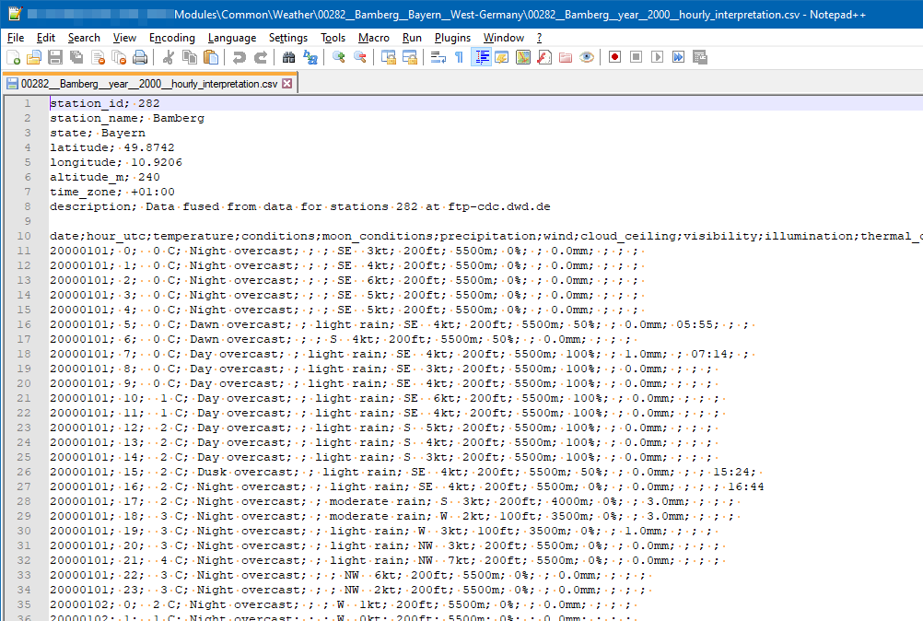

The .csv semi-colon separated files are better loaded and inspected in a spreadsheet application such as LibreOffice Calc or Microsoft Excel (after indicating that the semi-colon is the separator):

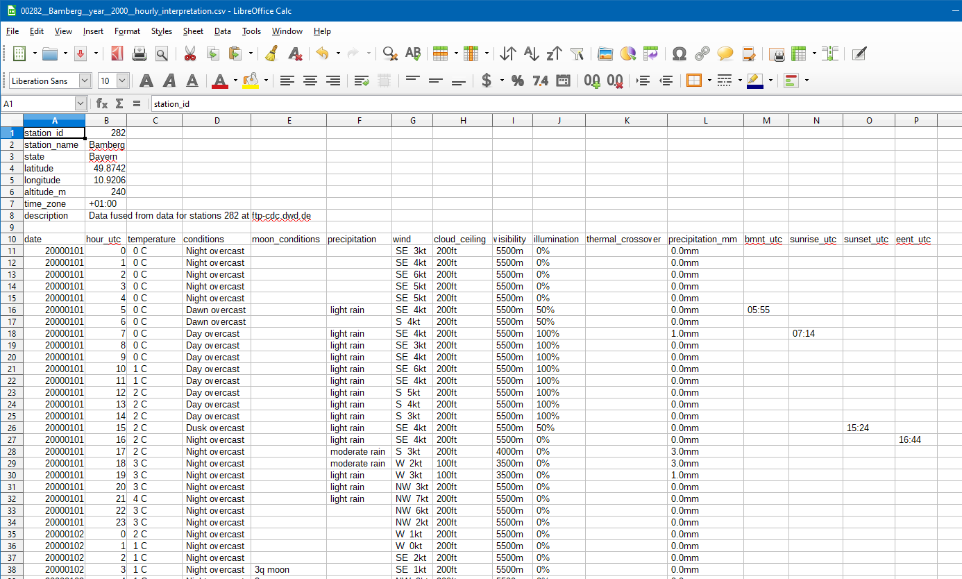

After a header and a blank row, the bulk of the data follows, in 16 columns. The first row defines the header and is followed by 365 or 366 days of 24 hours of weather.

The table below describes each columns meaning, supported measurement units, and expected format:

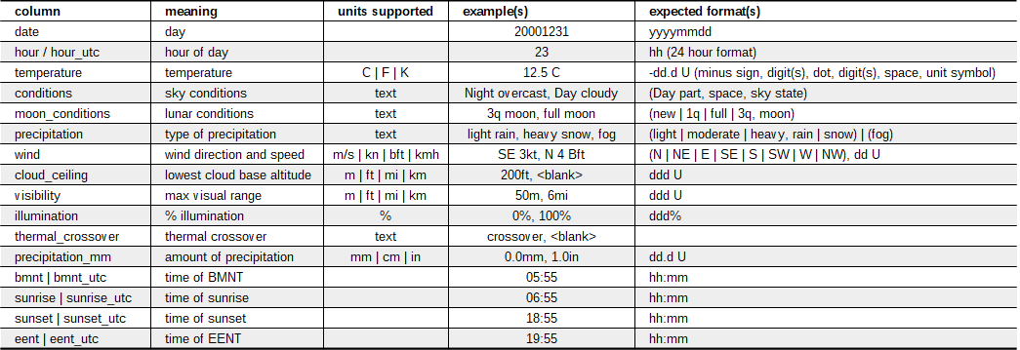

Notes:

* In the current version of Flashpoint Campaigns, the thermal crossover column is ignored, and thermal crossover is assumed to occur during dawn and during dusk.
* In the current version of Flashpoint Campaigns, the illumination column is ignored, and illumination is computed based on day phase (Night), lunar phase, and cloudiness.
* The ‘hour_utc’, ‘bmnt_utc’, ‘sunrise_utc’, ‘sunset_utc’, and ‘eent_utc’ column names are being replaced by just ‘hour’, ‘bmnt’, ‘sunrise’, ‘sunset’, and ‘eent’, to avoid the suggestion these are time zone specific.

## Weather Data File Contents Rules

The weather data file contents must conform to the following rules, in order to be a valid weather data file accepted by the game.

1. The file should have a header part, followed by a blank row/line, followed by the data part.
2. The header part should not contain blank rows/lines
3. The data part should consist of a single header row, followed by 365 days (or 366 days, for leap years) of 24 hours of weather data
4. The header row should contain column names, separated by semi-colons
5. The data rows should be in order of day and hour, covering each hour of the year in sequence
6. The ‘moon conditions’ column shall be blank if ‘conditions’ column does not include ‘Night’ (it still can be blank for ‘Night’)
7. Precipitation is blank, fog’, or gradation of either ‘rain’ or ‘snow’; valid gradations are ‘light’, ‘moderate’, and ‘heavy’.
8. Precipitation amount should follow the precipitation gradation that is amounts for moderate precipitation should be greater than for light precipitation, etc.
9. Wind direction is mandatory, even for 0m/s speed wind.
10. Cloud ceiling can either be blank (no clouds) or should be a number greater or equal to 0 height.
11. Illumination should be 100% for ‘day’. We use 50% for ‘dawn’ and ‘dusk’, and 0% for ‘nights’ without moon or overcast ‘nights’, and 40% for full moon clear ‘nights’.
12. Thermal crossover currently is ignored by the game.
13. A single bmtn entry should be filled out per day, in the corresponding hour’s row, and the same row should be tagged with ‘dawn’ conditions. For example, a 4:59hrs BMNT should be put in the hour ‘4’ row, along with ‘Dawn’ in the conditions.
14. A single sunrise entry should be filled out per day, in the corresponding hour’s row, and the same row should be tagged with ‘day’ conditions. For example, a 5:59hrs Sunrise should be put in the hour ‘5’ row, along with ‘Day’ in the conditions.
15. A single sunset entry should be filled out per day, in the corresponding hour’s row, and the same row should be tagged with ‘dusk’ conditions. For example, a 15:59hrs Sunset should be put in the hour ‘15’ row, along with ‘Dusk’ in the conditions.
16. A single eent entry should be filled out per day, in the corresponding hour’s row, and the same row should be tagged with ‘night’ conditions. For example, a 16:59hrs EENT should be put in the hour ‘16’ row, along with ‘Night’ in the conditions.

Note that the game does not impose consistency checks on the data: if the data says ‘fog’ and ‘visible: 10000m’, it will happily accept that.

# Tips for Creating Your Own Weather Data

This section describes two ways of creating your own weather data. The first way is aimed at small amounts of weather data, can be performed manually, and is described in detail. It is a bit laborious though.

The second way is aimed at obtaining and processing bulk weather data, which is best done automatic. This approach is sketched in coarse strokes, as the source, quality and quantity of the data will determine the exact approach.

## Cloning and Manually Modifying

Let us say, we want to use pseudo-random July weather for the Salisbury Plains UK area, with three different weather days being sufficient for pseudo-random weather. Which means we need to obtain and enter 3 x 24 consecutive hours + 23 hours is approximately 96 hours of weather data.

The best way to achieve this is to clone and modify existing weather data, as follows:

* Clone a weather station folder in the Flashpoint Campaigns folder, subfolder Modules\Common\Weather. Let us copy and paste the ‘00282__Bamberg__Bayern__West-Germany’ folder and rename the copied folder. ‘manual_July__Middle_Wallop_Hampshire__United-Kingdom’. The exact name does not really matter, but why not indicate that the data was manually created for July and that we will obtain it from the Middle Wallop airfield weather station.

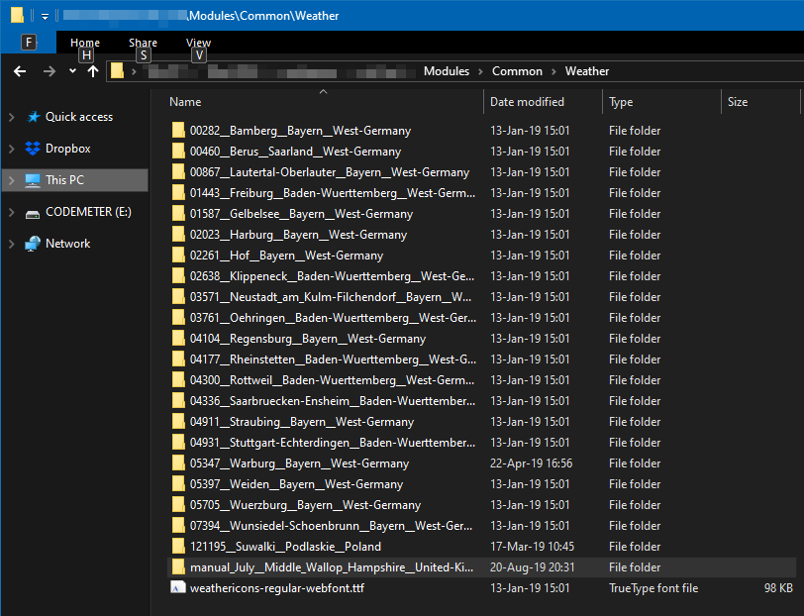

* Next, enter the newly cloned folder and remove all but one of the data files. Rename the remaining one to ‘manual__Middle_Wallop__year__2018__hourly_interpretation.csv’
* Open the renamed file with a spreadsheet tool (LibreOffice’s Calc or Microsoft’s Excel) and accept semi-colons as separator.
* In the spreadsheet, it’s recommended to freeze the top 10 rows, so the header stays in view.
* Scroll down to July 1st, hour 0, and clean rows for July 1st through July 4th except the date and hour columns

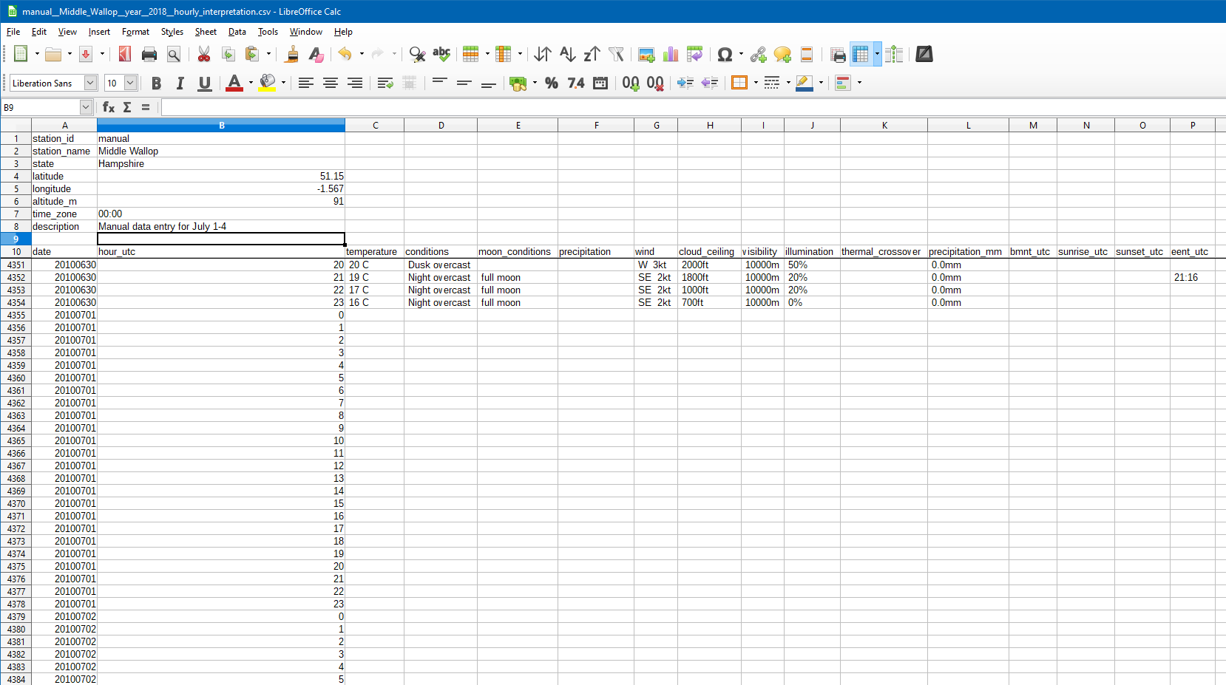

We need to obtain weather data to fill these empty cells. The web has plenty of weather sites offering historic weather data (but no sites offering all we need in one spot). We’re looking for Middle Wallop, July 2018 data.

Let’s browse to [www.timeanddate.com](http://www.timeanddate.com/), and search for Middle Wallop, bringing us to <https://www.timeanddate.com/weather/@2642574>. Here, we can ask for last weeks’ weather: <https://www.timeanddate.com/weather/@2642574/historic>. And select July 2018 as the month: <https://www.timeanddate.com/weather/@2642574/historic?month=7&year=2018>. Next, we click July 1 to get detailed weather:

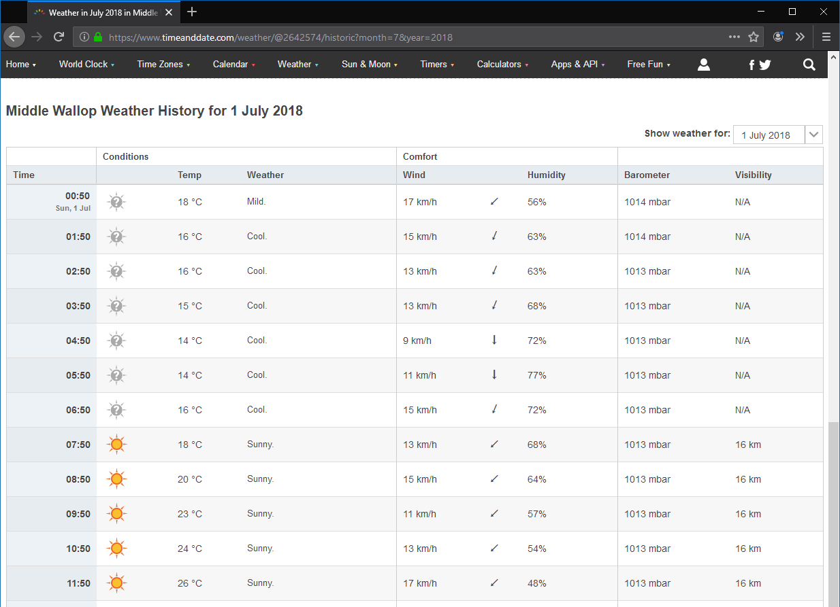

This web page gives us temperature, conditions, wind direction and wind speed, and visibility. Note that some of these fields require a bit of translation to match the required input as described in table **Error! Reference source not found.** above.

Specifically,

* The conditions need to be translated to ‘night clear’, ‘day clear’, ‘day cloudy’ and ‘night cloudy’ for July 1 (we’ll sort out Dawn and Dusk later).
* The wind direction needs to be spelled out, after reading the arrow.
* N/A visibility needs to be translated to 99999m.
* We need to guess the precipitation amount for those few moments it rains or sprinkles.
* We ignore dawn and dusk for the moment.

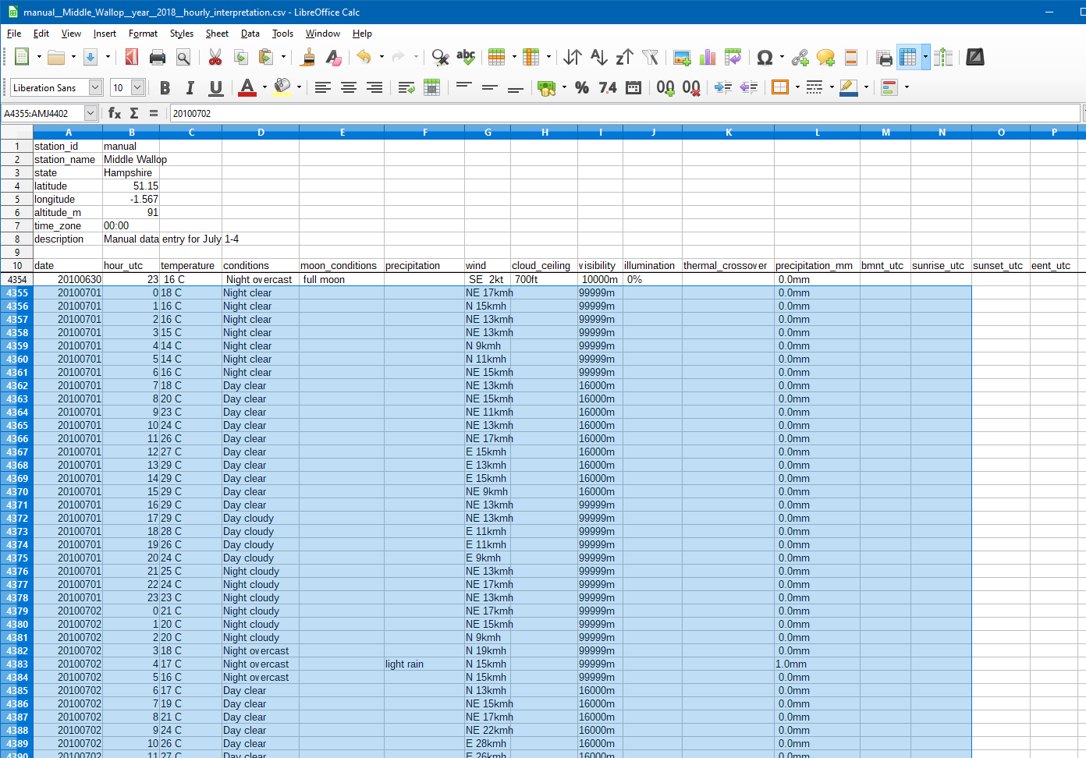

Next, on the same web site, we can find the dawn and dusk times. Click the ‘Sun & Moon’ drop down below the Middle Wallop banner, then select ‘Sunrise & Sunset’. It brings you to: <https://www.timeanddate.com/sun/@2642574>. In the lower part of the page, change the month and year to July 2018 (<https://www.timeanddate.com/sun/@2642574?month=7&year=2018>).

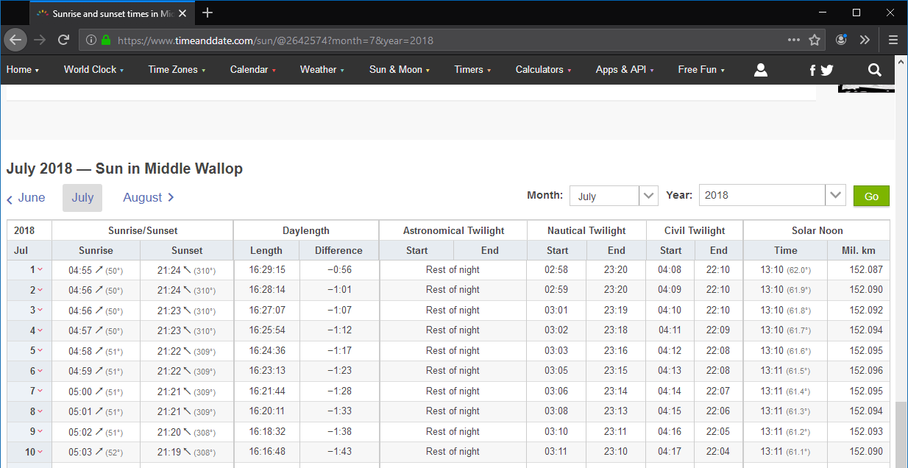

From the web site, we take the BMNT, Sunrise, Sunset and EENT for the first four days of July. We enter these in the corresponding column and hour rows. Next, we change the Day or Night designations in conditions to reflect Dawn or Dusk for the hours in which dawn or dusk starts or continues for the full hour.

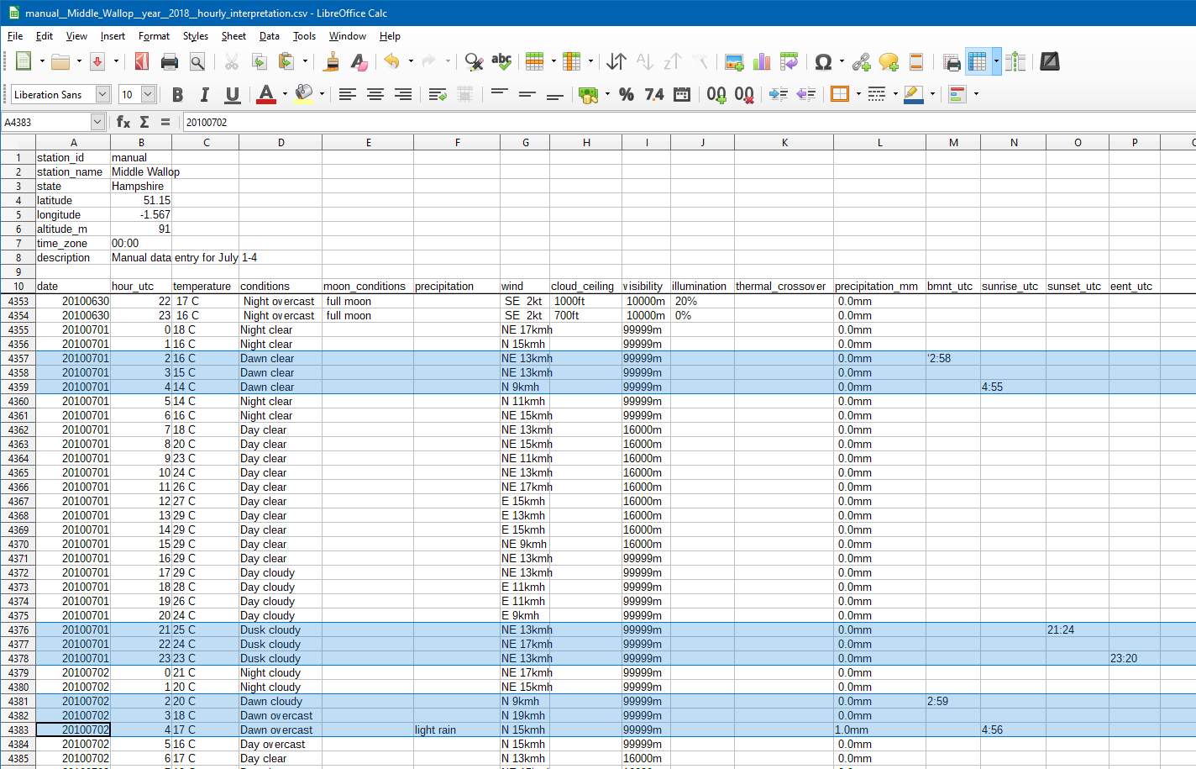

Again, from the same web site, we obtain moon timings and lunar phase. Click the ‘Moonrise and Moonset’ drop down below the Middle Wallop banner, then select the month July 2018 again: <https://www.timeanddate.com/moon/@2642574?month=7&year=2018>.

It tells us we have third quarter moon, rising after 23:00hrs or later, and setting between 08:00hrs and 10:00hrs for the first days of July 2018.

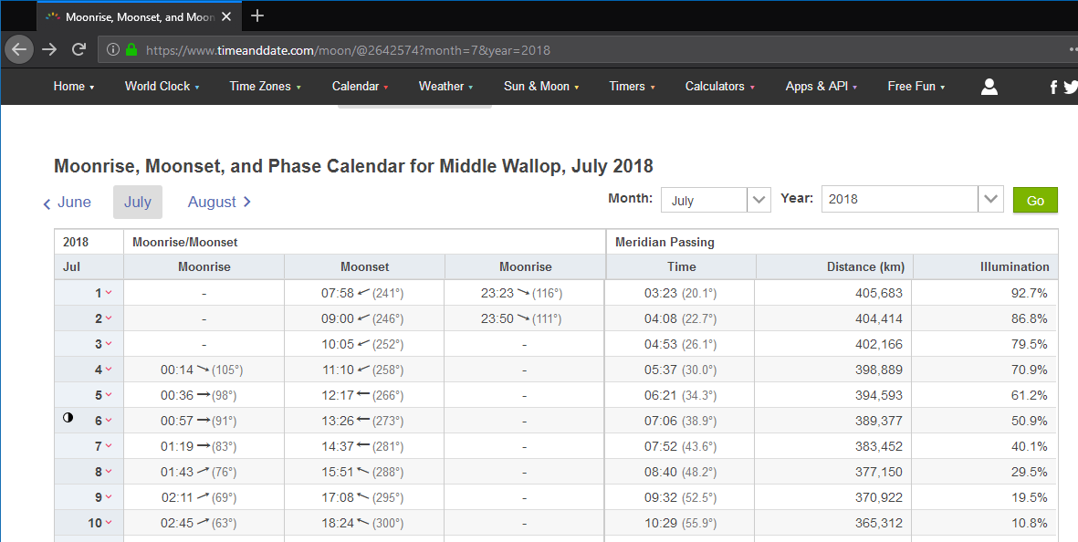

With this data, we can fill out the moon conditions column and complete the illumination column. We only report the moon during the night. Dawn and dusk have 50% illumination, and the 3q moon adds 30% illumination on clear nights, and 10% on overcast nights.

(Note that the web site indicates illumination data for the moon, whereas we are interested in world illumination in Middle Wallop. Do not copy the illumination data from the moonrise and moonset data on the web).

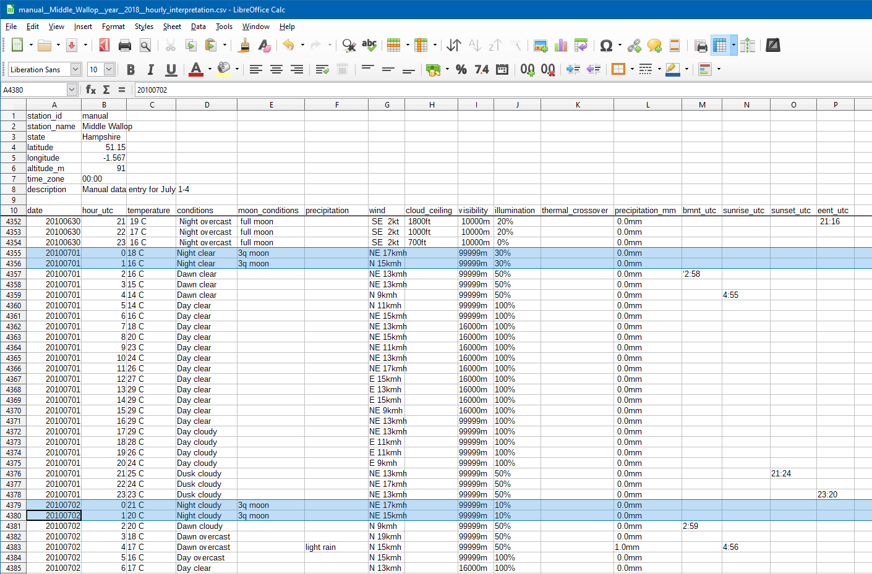

The final missing piece is cloud ceiling data (altitude of the base of the lowest cloud formation). Not all weather stations collect and report this, but most airfields do. With Middle Wallop also featuring an airfield (ICAO: EGVP), we can obtain cloud ceiling data as follows. On the web, go to Iowa State University’s collection of airports ASOS-AWOS-METAR Data: <https://mesonet.agron.iastate.edu/request/download.phtml>.

For Middle Wallop, UK, select the Great Britain ASOS network, and switch to that network: <https://mesonet.agron.iastate.edu/request/download.phtml?network=GB__ASOS>. Next, search for Wallop or EGVP, and select the EGVP Middle Wallop station. Finally, select the ‘Cloud Height Level 1 [ft]’ column, and set the date range to 2018 July 1 – 2018 July 5 (not July 4!), using the local UK (GMT/UTC time zone), and press ‘Get Data’.

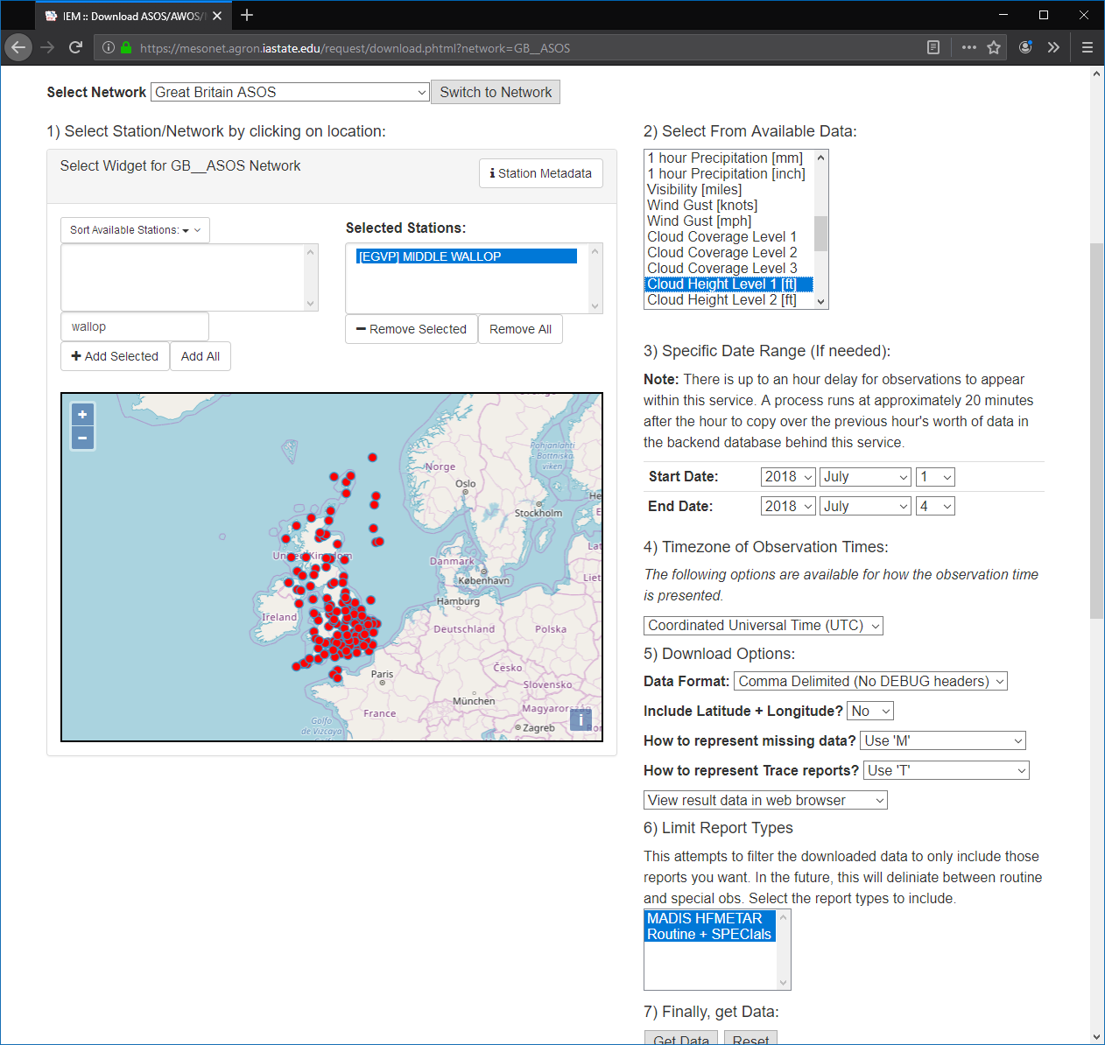

This will return a list of ‘skyl1’ observations in feet, with ‘M’ denoting ‘no clouds’ or missing data.

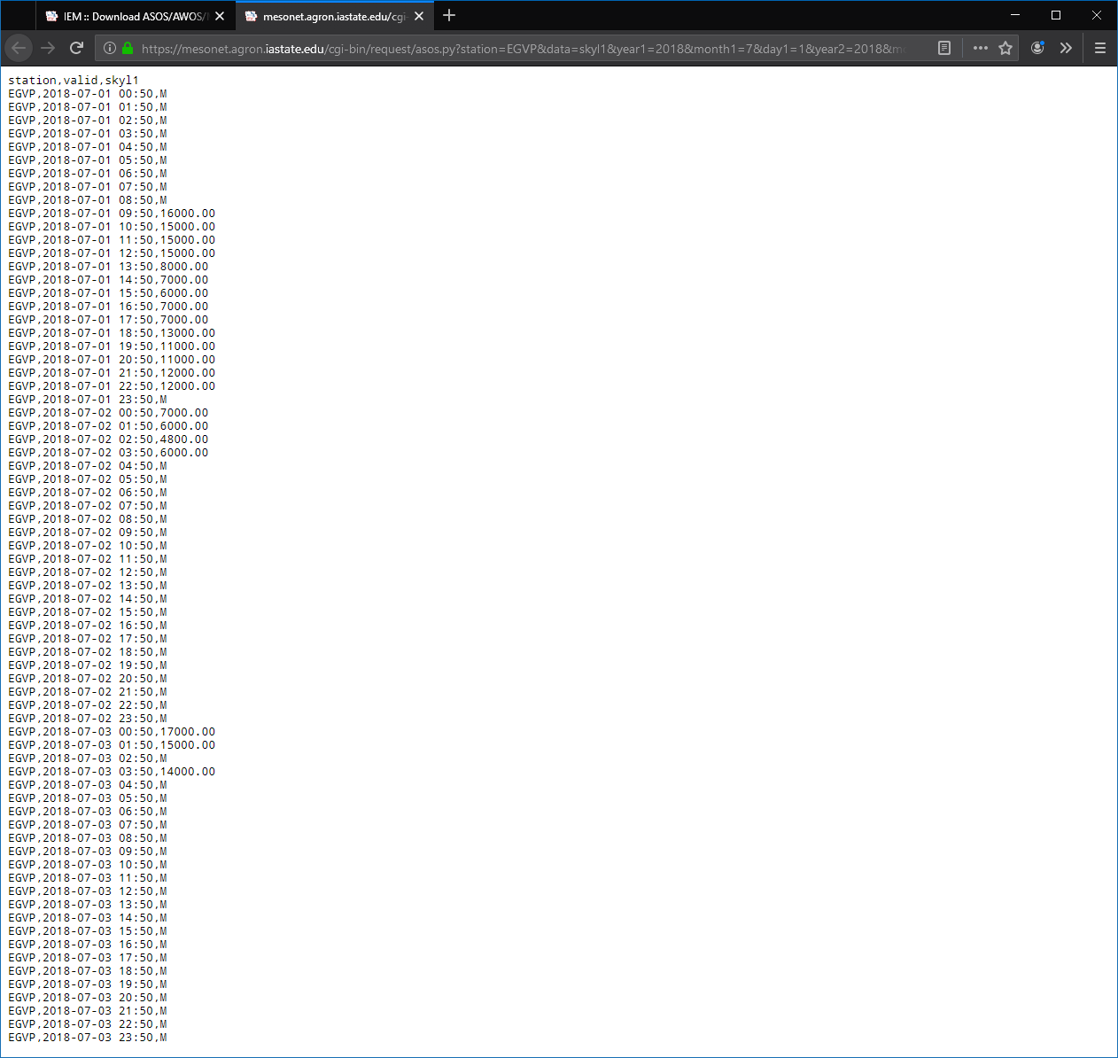

We can use this data to complete our weather data, leaving the column blank for ‘no clouds’, and entering the height in feet for those hours when clouds were observed, and our weather is cloudy or overcast. In the case that the web data is ‘M’ while our data is cloudy or overcast, interpolate, or extrapolate nearby cloud ceiling values.

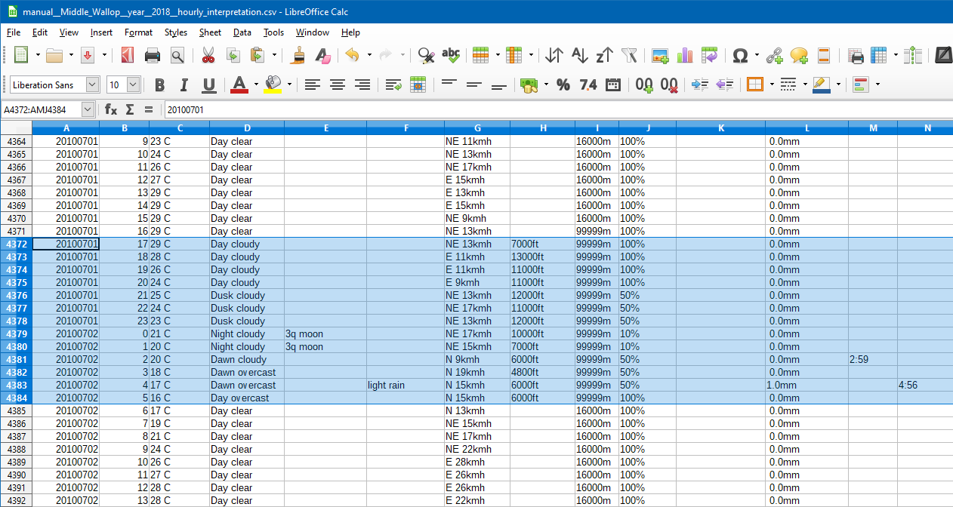

This completes our data entry. Save the file as .csv file.

It’s best to check the saved .csv text file with a text editor to see if the spreadsheet application wrote it with the right separator (a semi-colon), and with the header being separated from the bulk data by a blank line. If not, then try replacing tabs with semi-colons, and make sure there is a single blank line between the header lines and the bulk data.

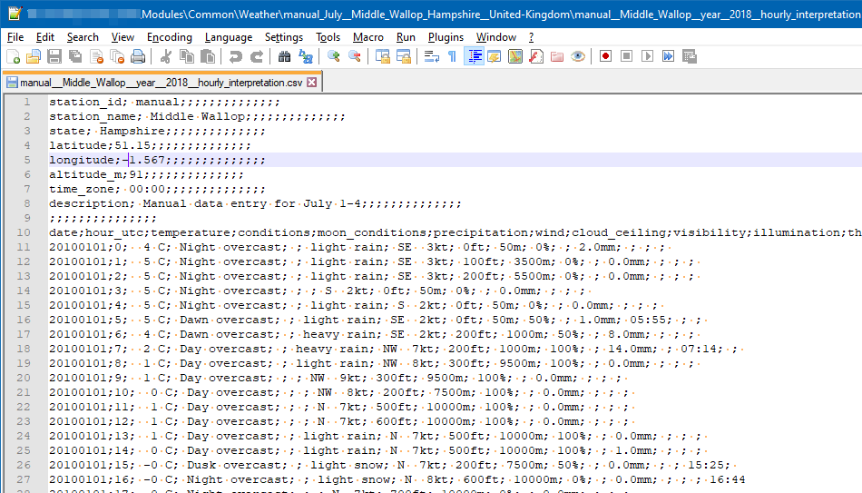

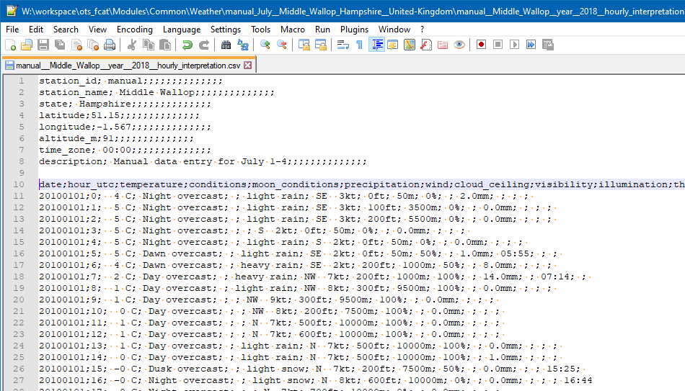

Now, it is finally time to load the data into our Scenario Editor… In the Scenario Editor, just change to the ‘Scenario Parameters’ screen, and press the ‘Weather Selection…’ button.

In Weather Selection dialog, use the ‘Select Weather Area’ Station dropdown list to scroll to and select manual_July_Middle-Wallop… Press the ‘Load Station Weather’ button. Under ‘Select Year(s) of Data’, select ‘All’.

Then, to use the 3 days + 23 hours we created for weather, select July (7) for month, and select 2 for day, with a 1-day range. Finally, press the ‘4. Select Weather Data’ button:

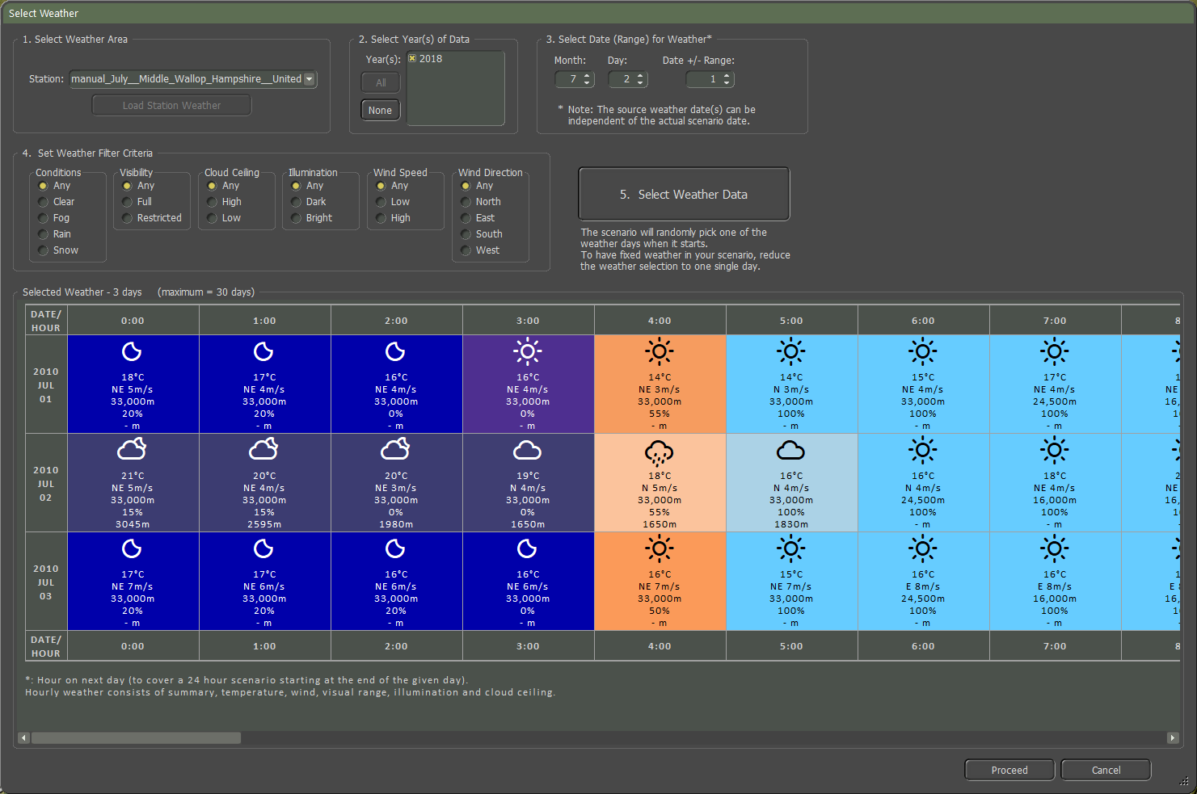

Press Proceed to use a pseudo-random selection from these 3 days of Salisbury Plains weather in your scenario.

## Obtaining and Processing in Bulk

Although it is clearly possible to create weather data files by hand, this is slow and tedious. With some programming and data processing skills, it is also feasible to automate the generation of weather data by processing weather observations in bulk. This is fast, but still tedious, mostly due to absent information and missing observations.

This section describes hints and tips on how we would approach this based on what we learned and discovered during our ‘journey’ to create weather data files for Flashpoint Campaigns.

### Data Source

For historic hourly weather observation bulk data across the world, we recommend the (free and public) US NOAA (National Oceanic and Atmospheric Administration) collection of data.

Given a lat/long coordinate pair for the map area of interest, first check the text file <ftp://ftp.ncdc.noaa.gov/pub/data/noaa/isd-history.txt> for a nearby listed station with recent observations. For example,

* For the Salisbury Plains, Middle Wallop is listed (as station with ISD identifier 037490):  
  037490 99999 MIDDLE WALLOP UK EGVP +51.150 -001.567 +0091.0 19730809 20190125
* For NTC Ft Irwin, California, Bicycle Lake AAF is listed (as station with ISD identifier 746110):  
  746110 03182 BICYCLE LAKE FORT IRWIN AAF US CA KBYS +35.283 -116.633 +0075.6 20050814 20190126

The ISD identifier then is the key to ftp folders of NOAA data by year. For 037490 Middle Wallop, the 2018 data is in:

* ftp://ftp.ncdc.noaa.gov/pub/data/noaa/2018/037490-99999-2018.gz

For 746110 Bicycle Lake AAF, the 2010 data is in:

* ftp://ftp.ncdc.noaa.gov/pub/data/noaa/2010/746110-99999-2010.gz

The .gz files are compressed text files containing ISD format records, ordered by observation time:

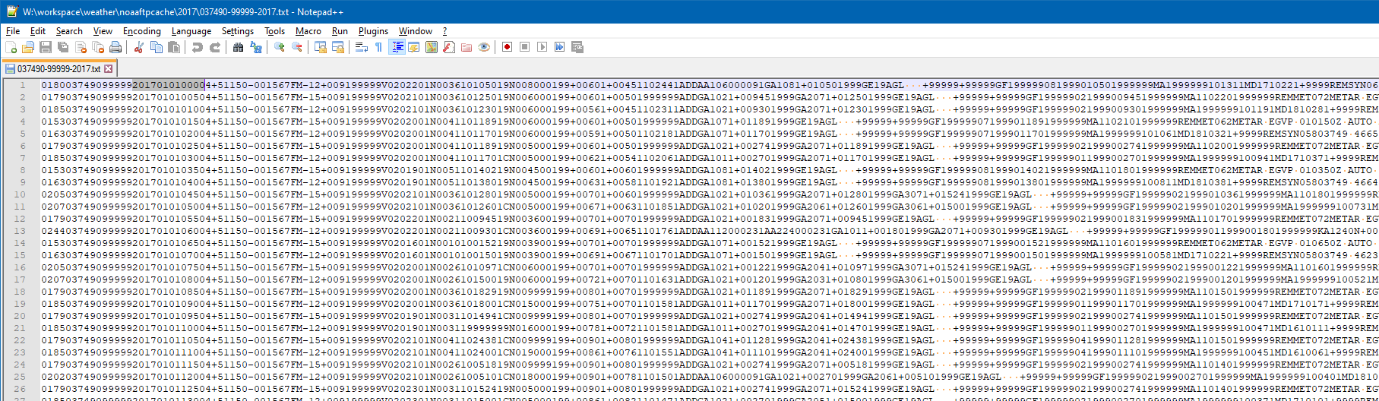

Each row is a record, with the first part in a mandatory fixed format, and optional information appended (including METAR info). The ISD format is documented in the ‘ish-format-document.pdf’, available here: <https://www1.ncdc.noaa.gov/pub/data/ish/ish-format-document.pdf> (2015 doc).

The mandatory fixed format provides wind, cloud base, visibility, and temperature information. The optional information (‘GA’) provides cloudiness information, and, as part of METAR records, precipitation, and fog information, although not always with precipitation amount values.

To complete this information, algorithms can provide the dawn and dusk timings, the lunar phase, and the moonrise and moonset timing for a given day, latlong position and time zone. Especially for the moonrise and moonset timings, it is nontrivial to find algorithms.

Next, augment the data with computed values (illumination, and estimates precipitation amounts given the METAR precipitation coding).

Finally, the data needs some repairing, by chronologically going through the hourly measurements and extrapolating values for missing observations.

### Processing

If we were to solve this problem anew, with all these lessons learned, we’d probably pick the R language/environment to do the processing. The data frames convert easily to the .csv output our game requires. For R, there are public libraries available that read NOAA ISD data ( <https://github.com/ropensci/isdparser> ), and compute sun / moon timings ( <https://github.com/datastorm-open/suncalc> ).

# Flashpoint Campaigns Credits

## On Target Simulations

* Lead Programmer and Head Honcho: **Robert "Ironman" Crandall**
* Data, Programming, Graphics, and Sound: **Jim "Cap’n Darwin” Snyder**
* Programming, Data, Models, and Research: **Jeff “Iron Mike” Sugden**
* Map Master, Programmer, AI, and Graphics: **William van der Sterren**
* Quality Czar and Testing Lead: **Charles “The Whip” Belva**
* Programming: **Kevin “SgtZDog” Zemon, Will Jackson, Alex Kriesel**
* Testing: **Tomasz Niedzinski**

## On Target Simulations Content Team

* Alexander “Stimpak” Schwarz, David “22sec” Whitt, Mike “MikeJ19” Johnstone, Joao Lima, Jurrie van der Zwaan, John “JohnO” Osborne, Jorgen “Jotte” Torgersson, Jo van der Pluym, Scott “WABAC” Gibbs and Steve “Mad Russian” Overton

## Cold War Beta Testers

* To be added before release!

## Matrix Production Support

* **Erik Rutins, Maxim Klose-Ivanov**

# On Target Simulations on the Web

Matrix Games Forum: <https://www.matrixgames.com/forums/viewforum.php?f=10149>

Check Us Out on Discord: <https://discord.com/channels/911711314051739659/911711314257248331>

Check Us Out on Steam: *“Pending a page URL*”

**© 2025 On Target Simulations (OTS), LTD. All Rights Reserved. The images used and OTS Logo are property of On Target Simulations, LTD. All other marks and trademarks are the property of their respective owners.**